
Component Model
Robotic Cognition System for Wheelchair
Unicamp

Table of Contents
1 Purpose of this Document 3
2 Building Blocks 4
3 Interfaces 5
4 Mapping 6

Document Information
Project Name: | Project XXX
Prepared By: |  | Document Version No:
Title: | Solution Building Blocks | Document Version Date:
Reviewed By: |  | Review Date:
Distribution List
From | Date | Phone/Fax/Email

Acronyms
Acronym | Description
URDF | Unified Robot Description Format

To | Action* | Due Date | Phone/Fax/Email
* Action Types: Approve, Review, Inform, File, Action Required, Attend Meeting, Other (please specify)
Document Version History
Version  Number | Version  Date | Revised By | Description | Filename

Purpose of this Document
<<Solution Building Blocks (SBBs) relate to the Solutions Continuum, and may be either procured or developed.
SBB characteristics are:
- Define what products and components will implement the functionality
- Define the implementation
- Fulfil business requirements
- Be product or vendor-aware>>

Robot Simulation Components

Relationship Diagram
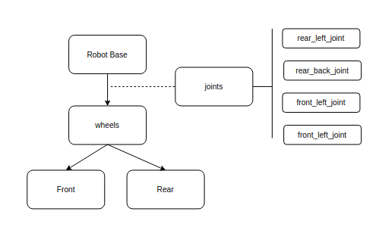

Iteration Diagram

Component description

Joints

The friction parameters:
- kp: Dynamically 'stiffness'-equivalent coefficient for contact joints (Rigidez)
- kd: Dynamically 'damping'-equivalent coefficient for contact joints (Amortecimento)
- mu: Coefficient of friction along the first friction direction
- mu2: Coefficient of friction along the second friction direction. For most cases, mu2 has same value with mu.

Laser Pointer

This is a laser pointer based on the Hokuyo lasers to point to a specific point in the ground where the robotised wheelchair user would like to go. This point information will be an input for UPD calculation processing to identify if that specific point is safe to be moved considering the current wheelchair robot set-up.
To add the tilt and pan functionality for this laser was added a pan and tilt base in the Hokuyo laser. This pan and tilt can be controlled by a user interface to simulate the movement of the laser ray.

Application Components
<<The purpose of this section is to outline specific functionality and attributes: semantic, unambiguous, including security capability and manageability.>>

Iteration Diagram

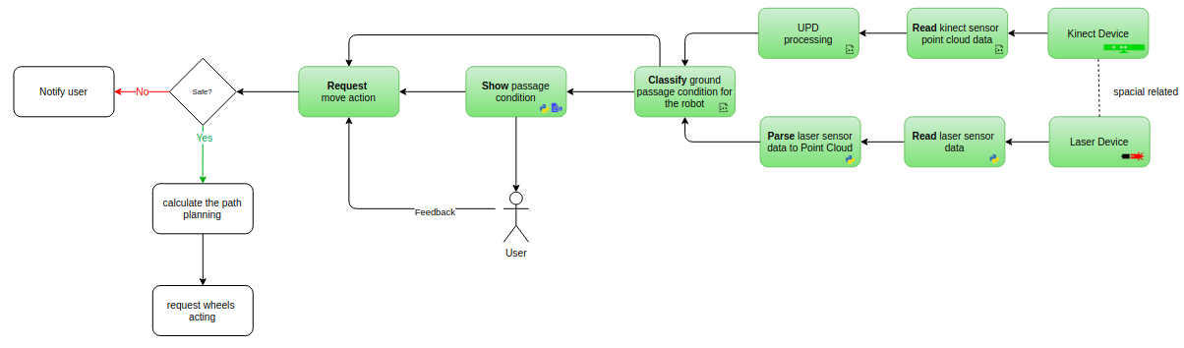

UPD processing
To be defined
- Frame rotations from kinect frame to world frame
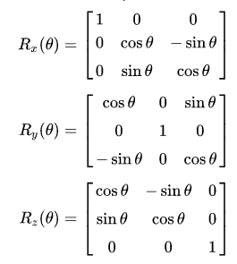

Point Cloud Data Reduction
The vox grid approach is being used to downsample the point cloud.

Parse laser pointer sensor data to point cloud
In order to have the laser pointer data in the point cloud format, the ROS python class LaserProjection from laser_geometry library is being used. This data will be an input to the Classify Robot Passage Condition component that will validate if the current location the user is pointing is passable or not for the current robot, considering the unevenness of the ground.

Simulation

This is a simulated wheelchair robot in Gazebo with a sensor kinect and a laser pointer sensor and a box object in front of it.
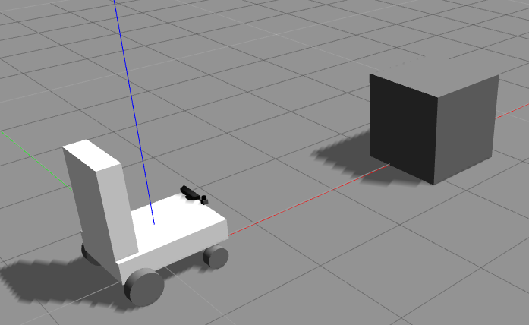

In the Rviz application the red pints are the point cloud data parsed from the laser data.

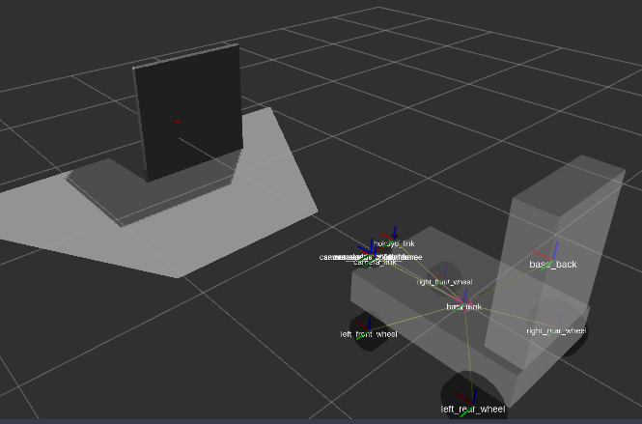

Code

#!/usr/bin/env python
import rospy
from sensor_msgs.msg import PointCloud2 as pc2
from sensor_msgs.msg import LaserScan
from laser_geometry import LaserProjection

class Laser2PointCloud():
def __init__(self):
self.laserProjection = LaserProjection()
self.laserPub = rospy.Publisher("/laser/point_cloud",pc2, queue_size=1)
self.subscriber = rospy.Subscriber("/laser/pointer", LaserScan, self.laserCallBack)

def laserCallBack(self,data):

cloud_out = self.laserProjection.projectLaser(data)
self.laserPub.publish(cloud_out)

if __name__ == '__main__':
rospy.init_node("laser2PointCloud")
l2pc = Laser2PointCloud()
rospy.spin()

Laser frame to Kinect frame transformation

To match the laser cloud data with UPD cloud data, the laser frame should be first translated to the Kinect device sensor frame. The current origin of Kinect in the simulated environment is xyz="0.50 0.2 0.15. The laser sensor origin is xyz="0.50 0.0 0.15". With the difference of 0.2 (20 centimetres) on y axis. Below the images from environment simulation, UPD data without laser to Kinect origin translation and UPD data after laser to Kinect origin translation.

- Environment simulation
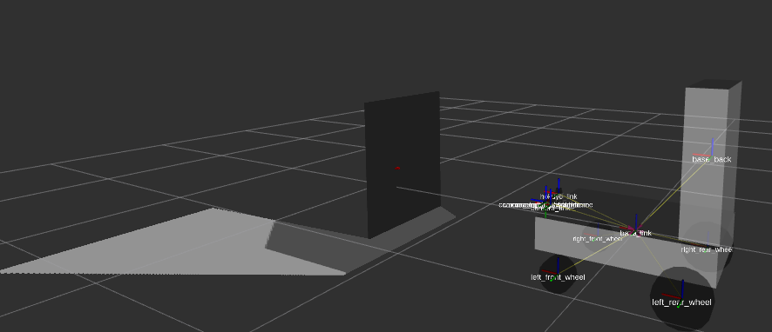

- UPD data without laser to Kinect origin translation

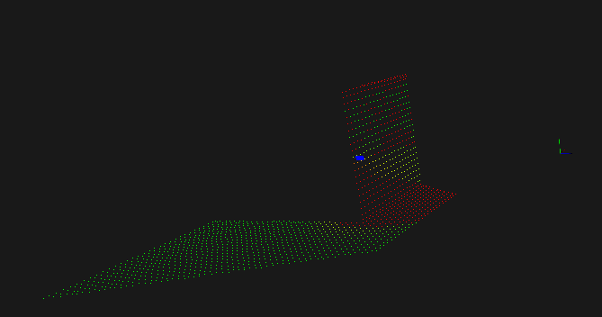

- UPD data after laser to Kinect origin translation

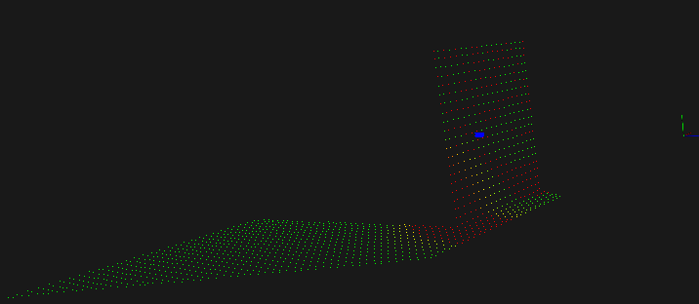

Classify ground passage condition for the robot
This component gets UPD data from current environment and the current laser pointer data parsed to point cloud and verifies if the laser is pointing to point cloud in UPD that are safe or not to be passed considering the current robot configuration. Link to the source code.

The main steps of this component:
- Defining the kdtree and the point object for the search
- Load the UPD cloud to kdtree object
- Iterate the laser points and search them on UPD cloud using kdtree algorithm
- Determine the passage condition
- Publish the passage condition

Laser Pan & Tilt transformation

Pan in Z axis
Tilt in Y axis

Show passage condition
This component gets the current passage condition classification where the user is pointing the laser and publish in a REST API the classification that can be rendered to the user in a Web page or a mobile phone. Link to the source code.

The main steps of this component:
- Define the ROS subscriber to passage condition classifier
- Define the API Web route that provides the passage condition classified
- Define a Web page to render with a green box for safe passage condition and red for unsafe

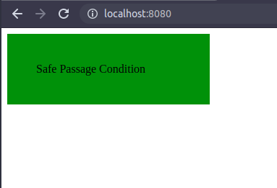

Control Laser Pan & Tilt
This component will control the laser pan and tilt. Below the rostopic sample command:
- rostopic pub -1 /r2d2_laser_controller/command std_msgs/Float64 "data: 0.1"
- rostopic pub -1 /r2d2_laser_pan_controller/command std_msgs/Float64 "data: 0.1"

The main steps of this component:
- Define the R

References

- Point Cloud
  - Downsampling a PointCloud using a VoxelGrid filter - http://vml.sakura.ne.jp/koeda/PCL/tutorials/html/voxel_grid.html
  - Voxel - https://en.wikipedia.org/wiki/Voxel
  - Accurate laser scanner to camera calibration with application to range sensor evaluation: https://link.springer.com/article/10.1186/s41074-017-0032-5
  - Convert Laser Scan to PointCloud: https://www.youtube.com/watch?v=GvilxcePD64
  - Estimate the transformation matrix between two set of points (PCL): https://machinelearning1.wordpress.com/2014/02/09/estimate-the-transformation-matrix-between-two-sets-of-points-pcl/
  - Search Point Cloud: https://www.researchgate.net/publication/325363391_Indexing_and_searching_point_clouds

- Simulation
  - Comparative Analysis Between Gazebo and V-REP Robotic Simulators - https://www.researchgate.net/publication/331688180_Comparative_Analysis_Between_Gazebo_and_V-REP_Robotic_Simulators
  - Bullet Real-Time Physics Simulation - https://pybullet.org/wordpress/
  - Open Dynamics Engine - https://sourceforge.net/projects/opende/
  - Simbody: Multibody Physics API - https://simtk.org/projects/simbody/
  - DART - http://dartsim.github.io/
  - Graphic rendering – OGRE - https://www.ogre3d.org/
  - Wheelchair URDF example: https://github.com/DTU-R3/URDF-ROS/tree/master/urdf
  - Wheelchair autonomous example: https://github.com/OSUrobotics/wheelchair-automation
  - Caster Wheel URDF example: https://github.com/qboticslabs/mastering_ros_robot_description_pkg/blob/master/urdf/diff_wheeled_robot.xacro
  - Caster Wheel URDF example 2: https://github.com/Toronto-Robotics-club/Gazebo_caster_sample/blob/master/jimmy_description/urdf/jimmy.xacro
  - ROS and Gazebo for Depth Camera: http://gazebosim.org/tutorials/?tut=ros_depth_camera
  - Pan & Tilt Gazebo Simulation: https://www.theconstructsim.com/pan-tilt-gazebo-simulation
  - Gazebo Joint Controller: http://gazebosim.org/tutorials/?tut=ros_control

- ROS
  - Control: http://wiki.ros.org/ros_control
  - ROS and Gazebo Tutorial: http://wiki.ros.org/action/fullsearch/urdf/Tutorials/Using%20a%20URDF%20in%20Gazebo?action=fullsearch&context=180&value=linkto%3A%22urdf%2FTutorials%2FUsing+a+URDF+in+Gazebo%22
- Wheelchairs examples
  - Example 1: https://www.dnrwheels.com/collections/power-mobility/products/economy-powerchair
  - Example 2: https://www.hedy-wheelchair.com/products/sew01.html
- Others
  - Rotation Matrix: https://en.wikipedia.org/wiki/Rotation_matrix
  - Rotating project point: http://www.pcl-users.org/Rotating-projected-point-cloud-to-get-z-0-for-all-points-td4034031i20.html
  - C++ Eigen Matrix: https://eigen.tuxfamily.org/dox/group__TutorialMatrixClass.html

Attributes
<< Specifications of attributes shared across the environment (not to be confused with functionality) such as security, manageability, localizability, scalability.>>

Performance

Configurability

Drivers and Constraints
<<Design drivers and constraints, including the physical architecture.>>

Interfaces
<<Interfaces: chosen set, supplied.>>

Overview

Interoperability
<<Interoperability and relationship with other building blocks.>>

Dependent Building Blocks
<<Describe dependent building blocks with required functionality and named user interfaces.>>

Required Solution Building Blocks
<<Required SBBs used with required functionality and names of the interfaces used.>>

Mapping

SBB Mapping
<<The purpose of this section is to describe mapping from the SBBs to the IT topology and operational policies.
Mandatory/optional: This section is mandatory.>>

Relationships Between SBBs and ABBs
<<The purpose of this section is to describe relationships between SBBs and ABBs.
Mandatory/optional: This-section is mandatory.>>

